**IRDIS Unpolarized Standard Star Observations May 2016 v2**

**Goal**

The goal of the observations is to empirically establish the diattenuation of M3 and M4 (part of the Mueller matrices describing the telescope (M3) and M4) when observing with IRDIS/DPI.

**Proposed observations**

* Same setup as the last observations of March 9, 2016
* Target: HD98161 (11 17 12.01 -38 00 51.7); additionally HD176425 (19 02 08.66 -41 54 36.3) (see Figure 2)
* BB_Y, BB_J, BB_H and BB_Ks filters
* NIR half wave plate
* P0_90 polarizer/analyzer set
* Derotator fixed in vertical position (θder = 0°) during all observations
* Adaptive optics turned off (open-loop)
* No neutral-density filters
* No coronagraph
* Detector integration time: sufficiently high photon count without entering the non-linear regime of the detector (for Y-band same as last time: 2.0 seconds)
* Number of detector integration times: 10 per HWP position, so 40 for a full HWP-cycle (Qplus, Qminus, Uplus, Uminus)
* For every filter, 3 blocks (at 3 very different altitude angles, and therefore automatically at different parallactic angles) of 2 full HWP-cycles. So in total 6 HWP cycles per filter, yielding 12 data points (6 Stokes q and 6 Stokes u) per filter (see Figure 1).
* For each block (altitude angle), perform 8 consecutive HWP-cycles in 4 filters in the order Y, J, H, Ks, Y, J, H, Ks (this order is to ensure that a filter is not measured at the same exact altitude angle twice, but has a slightly different value, resulting in a better fit).
* For each block (altitude angle), take a sky frame for every filter (4 sky frames per altitude angle) to allow for the removal of background polarization.
* When observing 1 star, perform the 8 HWP cycles at 3 very different altitude angles.
* When observing 2 stars, perform the 8 HWP cycles at 4 very different altitude angles (in this case the incident polarization of 2 stars needs to be fitted).

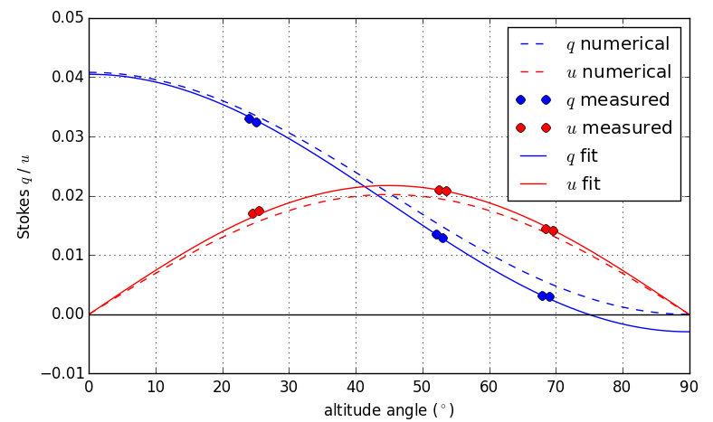

Figure 1: The best fit of the data is obtained when performing 2 HWP cycles per filter (yielding 2 q data point and 2 u data points) at 3 very different altitude angles. Data shown is simulated.

**Important notes**

* Measurements need to be performed at 3 very different altitude and parallactic angle combinations to distinguish between the effect of the diattenuations of M3 and M4, and between the diattenuations and the Stokes q and u of the source.
* When observing before and after meridian crossing, it is important not to measure at an altitude angle for which a measurement has already been taken, as this would yield no new information for fitting the parameters to the model.
* Avoid twilight and clouds during the observations.
* HD98161 and HD176425 have approximately the same magnitude, but their meridian crossings at a different time during the night, allowing more flexibility in the measurements.
* Attached is a .txt-file that shows the headers that should result after performing the measurements on 1 star (to clarify the measurements). Note that in reality the altitude angle would slowly change for every HWP position during a HWP-cycle and that the sky frames are not included in the list.

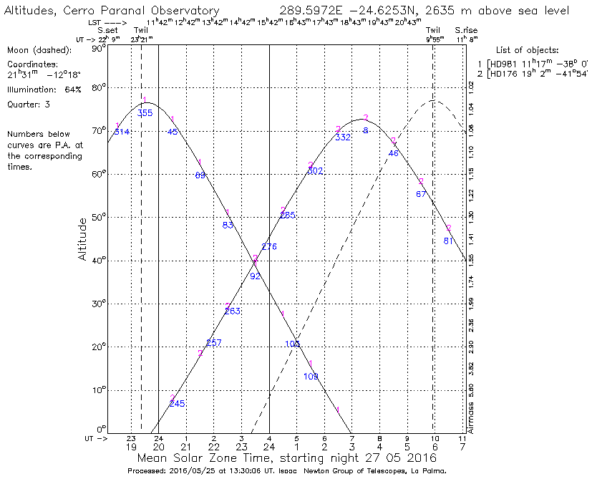

Figure 2: Altitude angles of HD98161 and HD176425 during the night of May 27 to 28, 2016.